NEW PATIENT INTAKE
Today’s Date_____________________________
Name___________________________________
Birth Date____/____/____ Age__________
SS#______________________________ E-mail Address________________________________________
Address_______________________________________________________________________
City__________________________ State__________ Zip Code__________________
Home Phone # ( ) _____-________ Cell Phone # ( ) _____-________ Work Phone# ( ) _____-________
Occupation_________________________________________ Currently pregnant_________
Do you have health insurance? Yes____ No____ Insurance Company________________________________
Plan/Group #______________________________
Do you have Medicare? ___________
Marital Status_____________ Name of Spouse_____________________________ # of Children________
Names and ages of Children ______________________________________________________
Main reason for consulting our office today: _______________________________________________________
___________________________________________________________________________________________
How did you hear about us? _____________________________________________
*Please check if you are here for any of the following: ____Car Accident ____Work Injury ____Other

I agree to pay for services rendered to the above mentioned patient as the charge is incurred. I understand and agree that health and accident insurance policies are an arrangement between the insurance carrier and myself and that I am personally responsible for payment of any and all the services covered or non-covered. I also understand that if I suspend or terminate my care and treatment, any fees for professional services rendered me will be immediately due and payable. I also give permission for Coron Family Chiropractic to render services to a minor without a guardian present.
Patient’s Signature________________________________________________ Date______________________
Guardian’s Signature ______________________________________________ Date______________________
Females only:
I certify that to the best of my knowledge I am not pregnant, and Coron Family Chiropractic has my permission to perform an X-ray evaluation if needed.
_______________________________________________________ ________________________________
Female Patient’s Signature Date

YOUR HEALTH PROFILE
Childhood Years (Age 0-17 years) – Please check those items that apply to you:
_____ Recurrent Childhood Illness _____ Serious Falls _____ Active in Sports
_____ Alcohol/ Drug Abuse _____ Surgery/Stitches _____ Car Accident(s)
_____ Smoker _____ Antibiotics/Other Meds _____ Vaccinated
_____ Under Chiropractic Care _____ Severe Emotional Stress _____ Broken Bones
_____ Other________________________________________________________________________________

Adult Years (Age 18 to Present) – Please check those items that apply to you:
_____ Present Smoker _____ Former Smoker _____ Alcohol Abuse
_____ OTC/Prescription Meds _____ Surgery/Stitches _____ Play Sports
_____ Car Accident(s) _____ Work Injury _____ High-Stress Job
_____ High Personal Stress _____ Sit A Lot _____ Drive A Lot
_____ Poor/Inadequate Diet _____ Poor Sleep _____ Not Enough Sleep
_____ No Exercise _____ Wear Orthotics/Lifts _____ Flat Feet
_____ Severe Health Problems _____ Hard Falls _____ Broken Bones
_____ Other Injuries_________________________________________________________________________
Have you been under chiropractic care in the past? _____________________________________
How long ago was your last adjustment? ____________________________________________

Past Health History
Have you... Yes No If yes, explain briefly:
…been hospitalized in the last 5 years? ______________________________________
…had any mental disorders? ______________________________________
…had any broken bones? ______________________________________
…had any strains or sprains? ______________________________________
…ever used orthotics? ______________________________________
Do you take minerals, herbs, or vitamins? ______________________________________
How is most of your day spent? standing sitting other: ________________________________
How old is your mattress? _________________________________
When was your last physical exam? __________________________

Habits
None Light Moderate Heavy
Alcohol
Coffee
Tobacco
Drugs
Exercise
Sleep
Soft drinks
Salty foods
Water
Sugar
Dairy

Family History
If any blood relative has had any of the following conditions, please check and indicate which relative(s):
Alcoholism Cancer High blood pressure
Anemia Diabetes High cholesterol
Arteriosclerosis Emphysema Multiple sclerosis
Arthritis Epilepsy Osteoporosis
Asthma Glaucoma Stroke
Bleed easily Heart Disease Thyroid disease

Patient Intake Form
Give a brief detailed description of the problem you are currently experiencing: ________________________
______________________________________________________________________________________________________________________________________________________________________________________________________________________________________________________________________________
How long have you had this condition? ___________________________ Is it getting worse? yes no
Does it bother you (check appropriate box): work sleep other: _____________________________
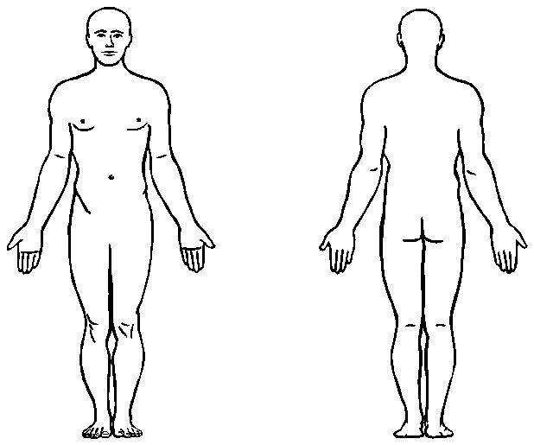
What seemed to be the initial cause? ___________________________________________________________

Please Mark areas of pain

Patient Intake Form (continued) Check box and indicate the age when you had any of the following:
GENERAL | GASTROINTESTINAL | CARDIOVASCULAR | CHECK ANY CONDITIONS
Allergies | Abdominal Pain | High blood pressure | YOU HAVE OR HAVE HAD:
Depression | Bloody or tarry stool | Low blood pressure | Alcoholism
Dizziness | Colitis Crohn’s | Hardening of the arteries | Anemia
Fainting | Constipation | Irregular pulse | Appendicitis
Fatigue | Diarrhea | Pain over heart | Arteriosclerosis
Fever | Difficult digestion | Palpitation | Asthma
Headaches | Diverticulosis | Poor circulation | Bronchitis
Loss of sleep | Bloated abdomen | Rapid heartbeat | Cancer
Mental illness | Excessive hunger | Slow heart beat | Chicken pox
Nervousness | Gallbladder trouble | Swelling of ankles | Cold sores
Tremors | Hernia |  | Diabetes
Weight loss | Hemorrhoids | RESPIRATORY | Eczema
Weight gain | Intestinal worms | Chest pain | Edema
 | Jaundice | Chronic cough | Emphysema
MUSCLE/JOINT | Liver trouble | Difficulty breathing | Epilepsy
Arthritis/rheumatism | Nausea | Hay fever | Goiter
Bursitis | Painful defecation | Shortness of breath | Gout
Foot trouble | Pain over stomach | Spitting up blood | Heartburn
Muscle weakness | Poor appetite | Wheezing | Heart disease
Low back pain | Vomiting |  | Hepatitis
Neck pain | Vomiting of blood | WOMEN ONLY | Herpes
Mid back pain |  | Congested breasts | High cholesterol
Joint pain | GENITOURINARY | Hot flashes | HIV/AID
 | Bedwetting | Lumps in breast | Influenza
SKIN | Bladder infection | Menopause | Malaria
Boils | Blood in urine | Vaginal discharge | Measles
Bruise easily | Kidney infection |  | Miscarriage
Dryness | Kidney stones | Menstrual flow | Multiple sclerosis
Hives or allergies | Prostate trouble | Regular Irregular | Mumps
Itching | Pus in urine | Pain/cramps | Numbness/tingling
Rash | Stress incontinence | Days of flow ________ | Pacemaker
Varicose veins |  | 1st day last period ________ | Osteoporosis
 | URINATION | Are you pregnant? _______ | Pneumonia
EYE, EAR, NOSE & THROAT | Overnight more than 2x | If yes, how many months? | Polio
Deafness | More than 8x in 24 hours | _______________ | Rheumatic fever
Ear ache | Decreased flow/force | How many children do | Stroke
Eye pain | Painful urination | you have? _____________ | Thyroid disease
Gum trouble | Urgency to urinate | Birth control method: | Tuberculosis
Hoarseness |  | _______________ | Ulcers
Nasal obstruction |  | Date of last PAP test?
Nosebleeds |  | _______________
Ringing of the ears |  | Date of last mammogram:
Sinus infection |  | _______________
Sore throat
Tonsillitis | Please bring a list or list any medication(s) you are currently taking and why:
Vision problems | ________________________________________________________________________
 | ________________________________________________________________________

PATIENT HEALTH INFORMATION CONSENT FORM
We want you to know how your Patient Health Information (PHI) is going to be used in this office and your rights concerning those records. Before we will begin any healthcare operations, we must require you to read and sign this consent form stating that you understand and agree with how your records will be used. If you would like to have a more detailed account of our policies and procedures concerning the privacy of your Patient Health Information we encourage you to read the HIPAA NOTICE that is available to you at the front desk before signing this consent.
- The patient understands and agrees to allow this chiropractic office to use their Patient Health Information (PHI) for the purpose of treatment, payment, healthcare operations, and coordination of care. As an example, the patient agrees to allow this chiropractic office to submit requested PHI to the health insurance company (or companies) provided to us by the patient for the purpose of payment. Be assured that this office will limit the release of all PHI to the minimum needed for what the insurance companies require for payment.

- The patient has the right to examine and obtain a copy of his or her own health records at any time and request corrections. The patient may request to know what disclosures have been made and submit in writing any further restrictions on the use of their PHI. Our office is not obligated to agree to those restrictions.

- A patient's written consent need only be obtained one time for all subsequent care given the patient in this office.

- The patient may provide a written request to revoke consent at any time during care. This would not affect the use of those records for the care given prior to the written request to revoke consent but would apply to any care given after the request has been presented.

- For your security and right to privacy, all staff have been trained in the area of patient record privacy, and a privacy official has been designated to enforce those procedures in our office. We have taken all precautions that are known by this office to assure that your records are not readily available to those who do not need them.

- Patients have the right to file a formal complaint with our privacy official about any possible violations of these policies and procedures.

- If the patient refuses to sign this consent for the purpose of treatment, payment, and healthcare operations, the chiropractic physician has the right to refuse to give care.
I have read and understand how my Patient Health Information (PHI) will be used, and I agree to these policies and procedures.
___________________________________________________________ _______________________
Name of Patient Date

